Chapter 19, Problem 76.

Use PSpice to obtain the z parameters of the network in Fig. 19.122.

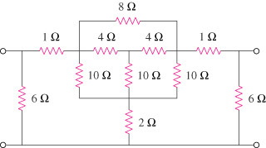

Figure 19.122
For Prob. 19.76.

